STAT 442 Final Project
Paralyzed Veterans of America (PVA)

Instructor, Professor De Veaux

by

Annie Ferguson
Jerry He
Arjun Narayan
Martin Rotemberg

May 11, 2008

Introduction:
Data Mining is often a combination of high-powered statistics and intuition. For our final project we are given a list of potential donors to Paralyzed Veterans of America (PVA), which is a not-for-profit organization that provides services to paralyzed US veterans. It has over 13 million donors, making it the largest direct mail fundraisers in the US. Our decision problem is to pick a subset of these people to mail requests for donation. Our independent data include not only past donation information on the potential donor, socio-economic characteristics of the donor, but demographic information on the neighborhood where the potential donor resides. PVA has given us some clues upon their concern of “lapsed” donors, which are individuals who made their last donation to PVA 13 to 24 months ago. PVA claims that the longer someone goes without donating, the less likely they will be to give again. This supports the theory that donation is a habitual phenomenon. Nevertheless, there inverse correlation between likelihood to respond and the dollar amount of the gift, so we think of donors as two categories, one which makes significant donations infrequently and another which makes insignificant donations frequently. Capturing the former is important to the PVA those people widens our profit margins but are frequently misclassified in a straight response model.
Upon first analysis, this data mining problem presents 3 distinct challenges, for which we need to handle with care. The first challenge is how to clean and express the past donation information into multiple variables so that current statistical techniques can more easily capture any useful interactions between the temporal component and the nominal component, between the nominal component and the potential donor’s socio-economic status and personal interests, and between the nominal component and the demographic characteristics of the potential donor as well as that of his neighbors.
The second challenge is how to balance false negatives and false positives, using the revenue function prescribed by PVA. Obviously, as a purely statistical problem one can predict quite “accurately” if we just assume everyone to be non-donors. This challenge may be complicated by the fact that perhaps people frequently move from one category to the other, perhaps a dominant type is one that donates a lot the first time but insignificant amounts subsequently.
The third and perhaps the most important challenge is to figure out novel ways to identify power donors, as those donors are statistically rare and may be of a different breed than the average donor. It may be wise to use two entirely different models to pick out power-donors vs. regular donors.

Data Cleaning:
PVA has a variety of codes that they use to describe their customers in terms of how often they've given, how recently they've given, and how much they've given. We decided that there was no reason to keep their groupings. Using their codes, we generated variables which described how many times someone gave in six month period from the last six months of 1994 to the last six months of 1996. There were only 500 people who gave in the last six months of 1996, which seemed odd. Furthermore, we generated variables capturing how much people gave in those periods. Inspired by Foster Provost's talk on the importance of networks, we generate neighborhoods which were the first three digits of people's zip codes. We generated variables which captured the amount of times someone in the neighborhood gave in each six month period, and how much was given by the neighborhood.
There were also a variety of variables with blanks. They fell into two categories: where the blanks meant "no", and where they actually were missing. When missing meant no, we replaced missing with 0. When missing was actually missing, we replaced missing with 0 and generated dummy variables which indicated if the variables were missing. For instance, if XXX had some missing entries, we would replace the missing ones with 0, and generate missingXXX =0, unless XXX was missing, in which case missingXXX=1. For many variables (such as the ones determined by survey), many variables were missing for the same entries, so we just generated one "missingXXX" variable.

Methods:
We will first describe the tools we have and our approach for tackling this problem. The data is gigantic, and thus we need to filter out variables that contribute from those that do not. We explored three different approaches 1) predict who will be likely to donate a lot, 2) predict who will definitely not donate, and 3) predict who will donate in general.
The first approach did not seem to produce any results since very few people are large donators. Using the second approach we determined large groups of individuals who have a very low probability of donating. One of these groups that contains 2063 individuals includes those where gavelast95==0, gavelast96==0, gavefirst96==0, veterans ==0, income <= 2, and income>0. The mean donation for this group is $0.50. The mean donation of the group containing 5690 individuals whose income==1, gavelast96==0, and gavefirst96==0 is $0.49. The group of 2265 individuals who are both female and younger than 36 have a mean donation of $0.57. There are 3978 females who are younger than 43, gavelast96=0, and gavefirst96=0 with a mean donation of $0.58. Lastly, if the origin date is between January 1995 February 1996, if veterans=0, gavelast96=0, and gavefirst96=0, the mean donation of 3400 individuals is $0.58. If the solicitation is sent to everyone, we would profit 10,770. If we dropped these groups, we would make a net revenue of 12,522 (in the trial dataset), losing 500 people who gave money (1/8 of the total).
KXEN is a powerful statistical software that can handle large data sets. We will first use KXEN to filter out important variables. A limitation to this approach could be that KXEN would drop variables that are not significant itself but significant in interaction with others. By running the program once on target_d and once on target_b, we compiled a list of top fifty variables. Later, due to computational resource constraints, we further narrowed down to 18 variables, variables state had to be removed because of having too many categories.
Here are the 18 variables:
ethc3: Percent White Age 60+
cardpm12: Number of card promotions received in the last 12 months
pepstrfl: Indicates PEP Star RFA Status
agec6: Percent Adults Age 65-74
vc4: Percent Veterans Serving After May 1975 Only
mhuc2: Median Homeowner Cost w/out Mortgage per Month dollars
lastgift: Dollar amount of most recent gift
rdate_8: Date the gift was received for 96GK
state: state abbreviation
lastdate: Date associated with the most recent gift
hv2: Average Home Value in hundreds
maxramnt: Dollar amount of largest gift to date
rdate_14: Date the gift was received for 95NK
hhn2: Percent 2 Person Households
gavelast95: last amount given in 1995
gavelast94: last amount given in 1994
areagiftsf96: sum of amount first96 by zip2
(italics indicate variables we created)

TreeNET is another commercial implementation that holds promise in selecting important variables, as it had surprisingly outperformed others in Week 5 tutorial. It lacks the ability to discern continuous relationships as well as MARS, but probably excels in categorical type classifications. However, TreeNET seems to not predict well on this data set, in fact TreeNET consistently gave stumps as answers. As for other methods, rpart seems to be overwhelmed by the data, and MARS could not handle the categorical variables. Thus, our 17 variables still stand unchallenged as the most important variables.
Armed with 17 `important` variables, we set out to explore the world of data mining techniques. We had thought Random Forest and Neural Nets worthy candidates to establish a benchmark. Both methods can handle quantitative outputs, and both methods excel in picking out nonlinear relationships reasonably well.
The first and foremost issue that came up was computational speed resources. With our own laptops and CS cluster computer, we were not able to run Random Forest, Boosting, or R implementation of MARS. Perhaps it was our puny CPU and RAM, or maybe it was just that R implementation on PC (and Linux) is inferior to the Mac R implementation. It turns out that all three could be run on the powerful Mac computer from Aalberts RNA lab.
Neural net, GLM, and Naïve Bayes all have considerable space and speed efficiency over the other techniques. For sake of experimentation, we also tried GLM with interactions, after 1 hour of stepping, it managed to reduce AIC from 554176 to 553412. So we doubted that it made any difference. We also hold disproportionate hope in Naïve Bayes, since process of elimination that seems to have worked so well is at its core a Bayesian approach
Finally we attempted to use MARS on just the 17 variables, with truly miserable results.
Results:
It is not entirely clear at this point how one should compare so many different methods. For lack of a better approach, we will first take a look at plots of predicted distributions and compare them to the actual distribution. Arguably, a reasonable model should produce similar distribution. Here are the respective distributions. Logit boost produced all 0’s, so it is not shown.
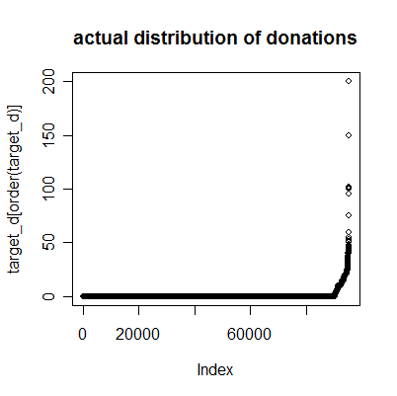
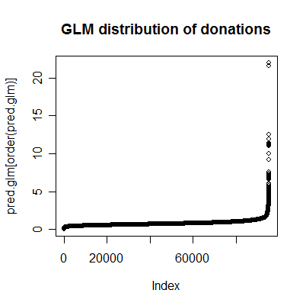

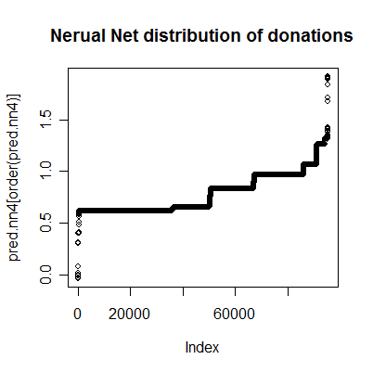
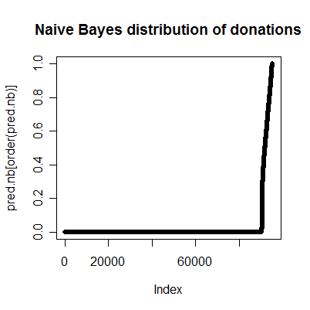

Distributions of course, only provide us with a qualitative idea. The final contest would come down to which method has the greatest profit making potential. Since we do not

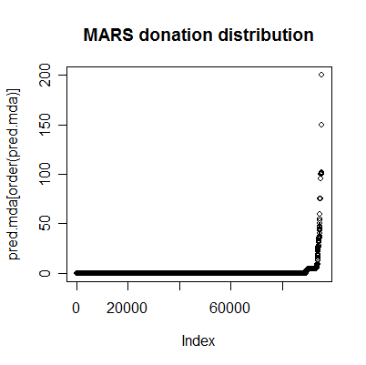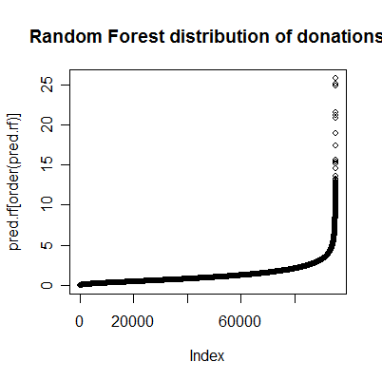

MARS seem to have predicted in the correct range, something no other method was able to accomplish. MARS has even attempted to reproduce the cusp in the original distribution, albeit incorrectly. Random Forest and GLM both have much smoother distribution than Naïve Bayes. Nonetheless, Naïve Bayes seems to have figured out almost exactly where to rise, this is quite remarkable, given that naïve Bayes is one of the fastest algorithms.
At this point, we will need to look for telling signs for where to set the threshold for donors. From the random forest graph, the cutoff seems to be around 5, and for Neural net, the cutoff seems to be around 0.6. Let us see if our intuition fits with what is actually profitable.

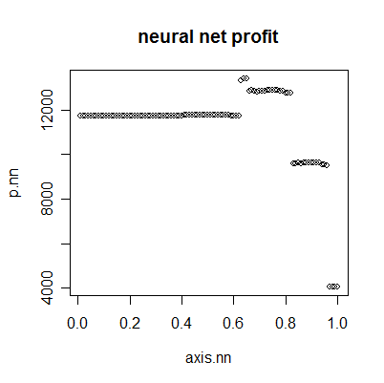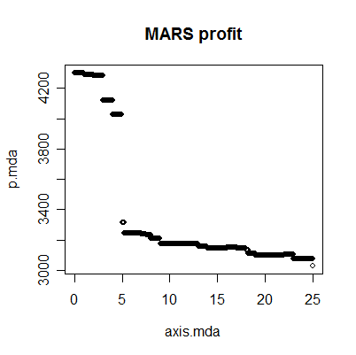
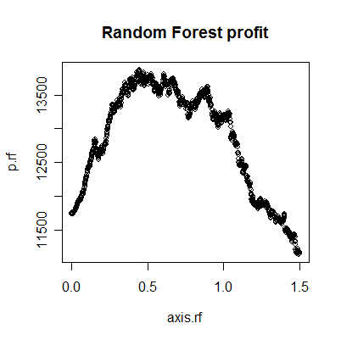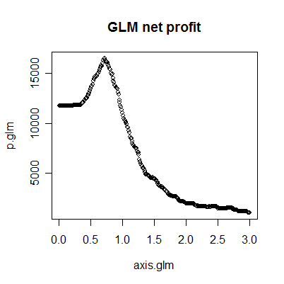
 | Max profit | Optimal threshold
GLM | 16506.3 | 0.72
Random Forest | 13869.41 | 0.44625
Neural Net | 13403.97 | 0.65
MARS | 4300.65 | A lot of ties

For Random Forest, 0.44 is an unjustified threshold, for GLM, 0.7 also seems a bit arbitrary, although it is possible that 0.7 is exactly half the flat slope height or 1/3, or 1/e. Nonetheless, as far as interpretability goes, neural net bests all other methods, as the cutoff is exactly at the longest plateau.
Now for the breaking news!!!
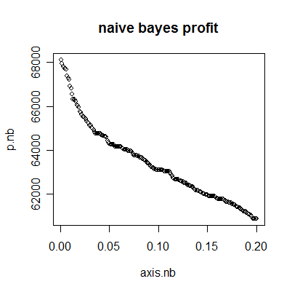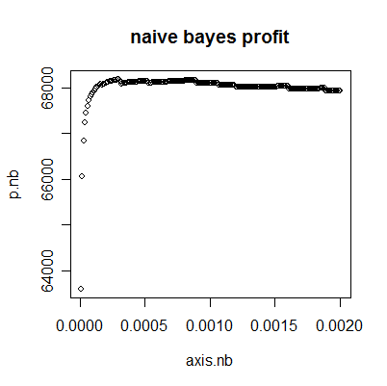
Max profit: $68183.91
Optimal cutoff: 0.0003
Quite astounding indeed, one can see how the independence assumption is quite valid given the 17 variables we used, but for them to achieve such synergy is nothing short of miracle, if not overfitting.

Analysis
We have learned that naïve Bayes is about as close to perfection as anyone could hopeful; we also learned that with Neural nets it is easier for us to set threshold We learned that Neural Networks is an effective learning technique for dealing with large data sets with a high signal to noise problem. Since the coefficients are meaningless, we cannot use neural networks for interpretation, but we can use it for purely predictive exercises. With the addition of more hidden layers, the model gets increasingly difficult to interpret. This technique also required us isolating a small percentage of variables. However, we run the risk of using the wrong variables since KXEN on occasions gave us very different answers.
We ran the neural net twice. The first time we trained the model on 50% of the training set, setting aside the other 50% to test. The second run, we used the entire training set to train the neural net and test. Both of these trials resulted in almost identical predictions. Therefore, we decided to not run cross-validation.

Final Results:
Neural networks gave us a list of predictions for target_d, and we choose a threshold, alpha-value, based on these predictions. By choosing a more conservative alpha-value, we decided to send it to a higher percentage of the test set, which can be seen in the plot below.
We settled on a conservative alpha value of 0.65, as seen by the line in the plot below. In addition to a conservative alpha value, we calculated a more liberal value of 0.8.

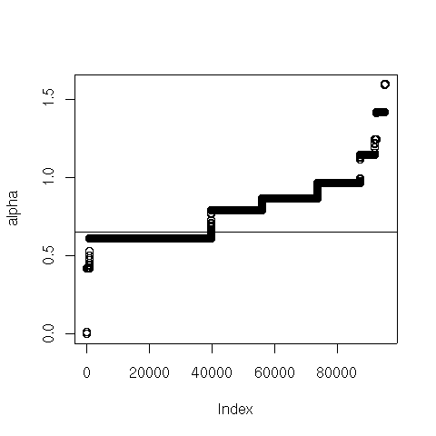
The plot below indicates the alpha value at which the profit is maximized in the training set.
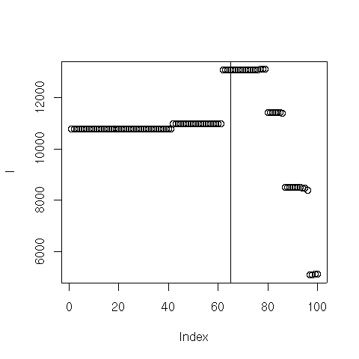

Conclusion:
Throwing naïve Bayes aside since it is too good to be true, we have decided to go with neural net. Despite the risk of over-fitting with neural net, we feel that it gives us the best model. We decided to choose a conservative alpha-value due to the wide variability in neural net results. Out of curiosity, we have also attached our predictions using a more risky threshold; we are interested in knowing whether or not the risky threshold does significantly better. We can see in the plot below that the pattern of alpha values we derive from the test set has the same shape and thus the same distribution as what we predict from the test set. This gives us hope that our result was robust to a reasonable degree.
